

AMERICAN INTERNATIONAL UNIVERSITY–BANGLADESH (AIUB)
Department of Computer Science
Faculty of Science & Technology (FST)
Fall 2024-25
Section: H, Group: 01

PROJECT TITLE

Virtual Classroom Platform: An Interactive, Accessible, and Engaging Online Learning Environment

Supervised By TONNY SHEKHA KAR

Submitted By

Group Members

SN | Name | ID
1 | AFNAN BIN ISLAM NAHIN | 22-49350-3
2 | AMAN ULLAH | 22-49345-3
3 | HRITTIK BHATTACHARJEE | 21-44650-1
4 | MD. HACHIBUR RAHMAN | 22-46426-1
5 | WALID BIN KHALED | 22-46101-1

PROJECT PROPOSAL

Abstract:

The Virtual Classroom Platform is a dynamic, interactive online learning solution designed to enhance remote education for students and instructors. In an era where virtual learning is essential, this platform offers a comprehensive suite of tools for real-time communication, content sharing, and student engagement. Core features include high-quality video conferencing, live chat, a digital whiteboard, breakout rooms, and interactive assessments like polls and quizzes. Additionally, the platform provides analytics and tracking dashboards, enabling instructors to monitor attendance, engagement, and academic progress.
With an emphasis on accessibility, data security, and regulatory compliance, this platform is designed for educational institutions, corporate training, and individual instructors. Scalable cloud infrastructure and cross-platform compatibility ensure reliability on various devices, from desktops to mobile. By facilitating a seamless, interactive, and secure learning experience, the Virtual Classroom Platform aims to meet the evolving needs of digital education and support active, engaging learning in a virtual environment.

Problem:

1. Limited Interaction and Engagement
- Problem: Many virtual platforms struggle to replicate the interactive dynamics of a physical classroom, resulting in reduced student engagement and passive learning.
- Impact: Decreased participation, lack of real-time feedback, and potential loss of interest.

2. Technical Issues and Accessibility Barriers
- Problem: Students and educators often face technical challenges such as connectivity issues, device compatibility, and software glitches.
- Impact: Disruptions in learning, frustration, and a decrease in learning efficiency.

3. High Dependency on Internet Connectivity
- Problem: A reliable internet connection is crucial, yet it’s not accessible to all students and educators, particularly in remote or under-resourced areas.
- Impact: Limited access to learning resources, interruptions in classes, and unequal opportunities for students.

4. Lack of a Unified User Experience Across Devices
- Problem: Platforms sometimes lack consistency in user experience across different devices (mobile, tablet, desktop), which can lead to confusion and frustration.
- Impact: Students and teachers face challenges navigating the platform, resulting in a less effective learning environment.

Solutions:

1. Limited Interaction and Engagement
- Solution: Introduce interactive features like real-time polling, quizzes, digital whiteboards, and breakout rooms to increase engagement. Include reaction emojis, hand-raising, and a live chat to allow students to participate actively. Gamification, like awarding points for participation, can also encourage interaction.

2. Technical Issues and Accessibility Barriers
- Solution: Optimize the platform for low-bandwidth environments and include device compatibility testing for multiple operating systems and devices. Provide offline access to learning materials and downloadable lecture recordings to help students continue learning even with connectivity issues. Regular updates and a dedicated support team can also help address glitches and device compatibility issues.

3. High Dependency on Internet Connectivity
- Solution: Offer offline capabilities where students can download lectures, resources, and assignments. Optimize the platform for low-bandwidth use and introduce a text-based chat mode for low connectivity situations. For areas with very limited access, provide downloadable resources and recorded lessons that can be viewed without internet.

4. Lack of a Unified User Experience Across Devices
- Solution: Implement responsive design principles to ensure a consistent experience on all devices, including desktops, tablets, and mobile phones. Conduct extensive testing across devices and provide a simplified interface that automatically adjusts to different screen sizes, making navigation easier and reducing user frustration.

Objective

The objective of the virtual classroom platform is to create an engaging and interactive online learning environment that enhances educational experiences for students and educators alike.

- Facilitate Seamless Learning: Provide a user-friendly interface that enables students to access course materials, submit assignments, and participate in discussions easily, promoting a seamless learning experience.
- Enhance Engagement and Interaction: Incorporate interactive tools such as live quizzes, polls, and breakout rooms to foster collaboration and engagement among students, helping them stay motivated and connected.
- Support Personalized Learning: Implement adaptive learning technologies that cater to individual learning styles and paces, allowing students to thrive in a personalized educational setting.
- Strengthen Community Building: Create a supportive online community where students and educators can collaborate, share resources, and offer peer support, enhancing the overall educational experience.

Functionality:

- Live Video and Audio Conferencing
- Screen Sharing
- Text Chat and Messaging
- Content Sharing and Resource Library
- Attendance Tracking
- Polls, Quizzes, and Assessments
- Session Recording and Playback
- Analytics and Reporting
- Push Notifications and Reminders
- Privacy and Security Features

Target Audience and how different groups can benefit by Virtual Classroom Platform:

- Students
Benefits:
    - Accessibility: Offers a flexible learning environment accessible from anywhere.
    - Collaboration: Provides tools for group projects and discussions, enhancing peer interaction.
    - Resource Sharing: Allows easy access to class materials, assignments, and resources.

- Teachers/Educators
Benefits:
    - Streamlined Teaching: Facilitates lesson planning and delivery through organized modules.
    - Engagement Tools: Incorporates interactive features like quizzes, polls, and forums to keep students engaged.
    - Assessment Tracking: Enables efficient tracking of student performance and progress through analytics.

- Parents
Benefits:
    - Involvement: Offers insights into their child’s learning journey and academic progress.
    - Communication: Facilitates direct communication with teachers through messaging features.
    - Resource Access: Provides access to educational resources to support learning at home.

- School Administrators
Benefits:
    - Management Tools: Simplifies administrative tasks, such as enrollment and attendance tracking.
    - Data Insights: Offers analytics to help improve curriculum and teaching methods based on student performance.
    - Scalability: Provides a platform that can grow with the institution, accommodating more students and courses as needed.

- Educational Institutions (Schools/Colleges)
Benefits:
    - Cost-Effectiveness: Reduces the need for physical infrastructure and materials, leading to cost savings.
    - Curriculum Development: Facilitates the creation and delivery of diverse courses, reaching a wider audience.
    - Brand Enhancement: Enhances institutional reputation by adopting modern educational technologies.

- Tutoring Services
Benefits:
    - Wider Reach: Allows tutors to connect with students beyond geographical limitations.
    - Resource Integration: Enables the sharing of learning materials and sessions through a centralized platform.
    - Customizable Learning Paths: Offers personalized tutoring options tailored to individual student needs.

Functional Requirements: Virtual Classroom Platform

User Registration

1.1 The platform shall allow new users (students and instructors) to register by entering a username, email, and password.
1.2 The registration process shall require verification via an email link sent to the user's registered email address.
1.3 Once verified, the user shall be able to log into the platform.

Priority Level: High
Precondition: User must have a valid email address.

Course Management

2.1 Instructors shall be able to create, edit, and delete courses on the platform.
2.2 Each course shall have a unique identifier and include fields such as course title, description, schedule, and list of enrolled students.
2.3 Instructors shall be able to add course materials (PDFs, videos, slides) and make them accessible to enrolled students.
Priority Level: High
Precondition: Instructor must be registered and logged in.

Virtual Classroom Sessions

3.1 Instructors shall be able to schedule live sessions for a course, specifying date and time.
3.2 Students shall receive notifications of upcoming live sessions.
3.3 Both instructors and students shall be able to join live sessions, which will support video/audio streaming, screen sharing, and a chat feature.
Priority Level: High
Precondition: Scheduled session must exist, and users must be enrolled in the course.

Assignment Submission

4.1 Instructors shall be able to create assignments, setting a deadline and grading criteria.
4.2 Students shall be able to submit assignments through the platform before the specified deadline.
4.3 Instructors shall have the option to review and grade assignments within the platform.
Priority Level: Medium
Precondition: Assignment must be created, and the student must be enrolled in the course.

Attendance Tracking

5.1 The system shall automatically record attendance for students participating in live sessions.
5.2 Instructors shall have access to view attendance records for each student in a given course.
5.3 The system shall notify students if their attendance falls below a specified threshold.
Priority Level: Medium
Precondition: Student must attend the live session for attendance to be recorded.

Grading and Feedback

6.1 Instructors shall be able to assign grades to students based on assignment performance and attendance.
6.2 The system shall allow instructors to provide written feedback on assignments.
6.3 Students shall have access to view their grades and feedback in their profile.
Priority Level: Medium
Precondition: Student must submit assignments and attend sessions.

User Profile Management

7.1 Each user shall have a profile page showing their personal information, enrolled courses, and grades.
7.2 Users shall be able to edit their profile information, such as email address and password.
7.3 The system shall allow users to view their login activity and manage security settings.
Priority Level: Low
Precondition: User must be logged in.

Notification System

8.1 The platform shall notify users of upcoming sessions, assignment deadlines, and grade updates.
8.2 Users shall have the option to customize their notification preferences.
8.3 Notifications shall be sent via email or in-platform alerts.
Priority Level: Low
Precondition: User must have an active profile with notifications enabled.

Non-Functional Requirements: Virtual Classroom Platform

Usability:
Description: A first-time user should be able to navigate the platform and join a virtual class session within five minutes without additional help.
Metric: 90% of users should be able to complete their initial tasks (e.g., joining a class, submitting an assignment) without assistance after their first login.
Priority Level: High
Precondition: User has access to a compatible device with a stable internet connection.

Performance:
Description: The platform shall support at least 500 concurrent users per session without noticeable degradation in video/audio quality.
Metric: Response time for accessing any page or feature should be under two seconds under normal load and a maximum of four seconds under peak load.
Priority Level: High
Precondition: Server infrastructure and internet bandwidth meet minimum requirements for load handling.

Reliability:
Description: The system should be available 99.5% of the time, excluding scheduled maintenance.
Metric: System downtime should not exceed 4 hours per month.
Priority Level: High
Precondition: Maintenance schedules and disaster recovery plans are implemented.

Scalability:
Description: The platform shall be able to scale to support an increase in users (up to 10,000 concurrent users) without requiring significant redesign.
Metric: System performance (page load times, video quality) should be maintained within acceptable limits as user count increases.
Priority Level: Medium
Precondition: Scalable architecture and cloud-based resources are available.

Security:
Description: All user data, including login credentials and personal information, shall be securely encrypted during transmission and storage.
Metric: The platform shall comply with industry-standard encryption protocols (e.g., SSL/TLS) and ensure data breaches are minimized to a risk level of less than 1%.
Priority Level: High
Precondition: Security policies are implemented and encryption mechanisms are in place.

Compatibility:
Description: The platform should be accessible on major web browsers (e.g., Chrome, Firefox, Safari) and be compatible with mobile devices (iOS and Android).
Metric: The platform should maintain full functionality on 90% of devices and browsers currently in common use.
Priority Level: Medium
Precondition: The latest versions of major browsers and operating systems are supported.

Maintainability:
Description: The platform codebase should be modular to allow future updates and changes without affecting existing functionality.
Metric: Updates and patches should be deployable with minimal downtime (less than 1 hour) and require no significant code rewrites.
Priority Level: Medium
Precondition: Codebase follows modular design principles and is well-documented.

Accessibility:
Description: The platform shall be compliant with accessibility standards (e.g., WCAG 2.1) to support users with disabilities.
Metric: 95% of all key features (classroom access, assignment submission) should be accessible via screen readers and keyboard navigation.
Priority Level: High
Precondition: Accessibility testing and inclusive design standards are integrated into development.

Project Development Constraints: Virtual Classroom Platform

Budget Constraints
- Description: The project must stay within a fixed budget, limiting available resources, tools, and technologies. This may restrict the ability to purchase premium software, hire additional developers, or implement advanced features.
- Priority Level: High
- Precondition: Initial budget assessment and allocation for essential features, resources, and tools.

Time Constraints
- Description: The platform must be developed and launched within a set timeline to meet educational institution schedules (e.g., the start of an academic semester). This may require prioritizing certain features over others to meet deadlines.
- Priority Level: High
- Precondition: Project plan and timeline are established, with key milestones defined for each development phase.
Technology Constraints

- Description: The platform must be compatible with existing infrastructure, such as specific operating systems, browsers, or hardware used by the educational institution. This may limit the choice of technologies and frameworks that can be used for development.
- Priority Level: High
- Precondition: Assessment of educational institution's existing technology environment and compatibility requirements.

Compliance Constraints
- Description: The platform must adhere to industry regulations and standards, such as FERPA (Family Educational Rights and Privacy Act) for student data privacy in the U.S., or GDPR (General Data Protection Regulation) for data protection if serving users in the EU.
- Priority Level: High
- Precondition: Identification of applicable regulations and requirements for compliance, with legal counsel or compliance experts consulted as necessary.

Resource Constraints

- Description: The project team may be limited in terms of available personnel, skills, and expertise. For instance, if there are limited UI/UX designers or cybersecurity experts, certain aspects of the platform may be constrained by available talent.
- Priority Level: Medium
- Precondition: Evaluation of team skills and identification of gaps, with potential recruitment or upskilling options explored as needed.
Scalability and Infrastructure Constraints

- Description: The platform must operate within the available server capacity or cloud infrastructure, which may limit the number of concurrent users and restrict certain features, such as real-time video conferencing.
- Priority Level: Medium
- Precondition: Review of existing server or cloud infrastructure to assess load-handling capacity and scalability.
Security Constraints
- Description: To ensure user data protection, the platform must follow stringent security protocols and encryption standards. This may require additional development time and restrict the use of certain third-party tools or plugins.
- Priority Level: High
Precondition: Establishment of security policies, with protocols defined for data encryption, secure data storage, and regular security audits.
Use case Diagram:

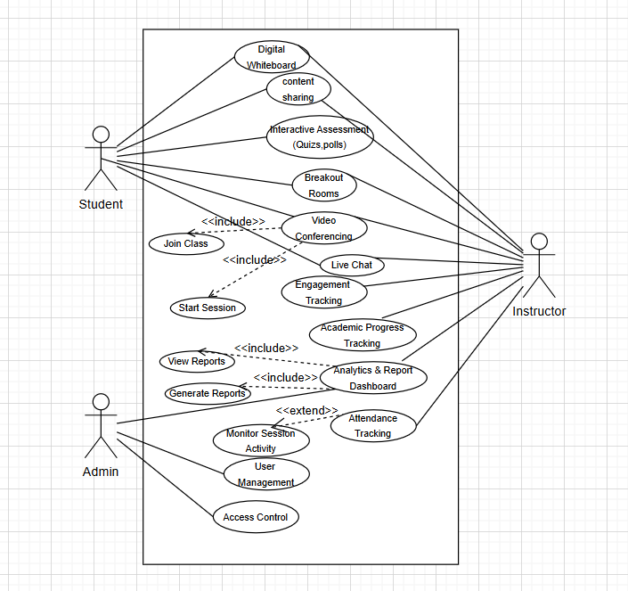

Class Diagram:

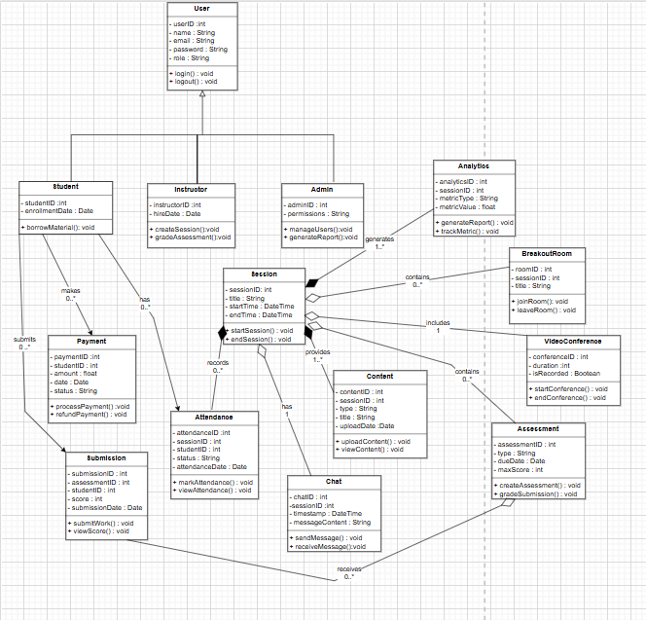

Activity Diagram:

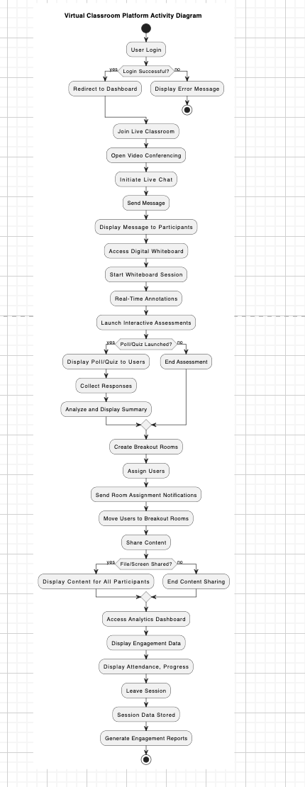

Sequence Diagram:

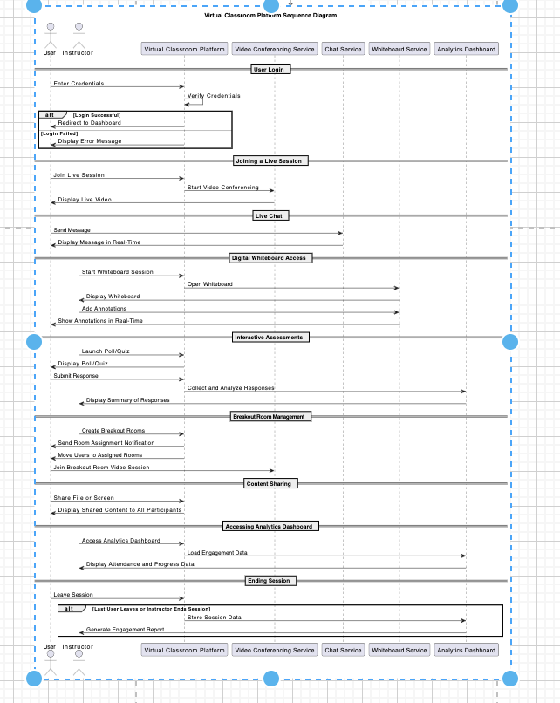

ER- Diagram:
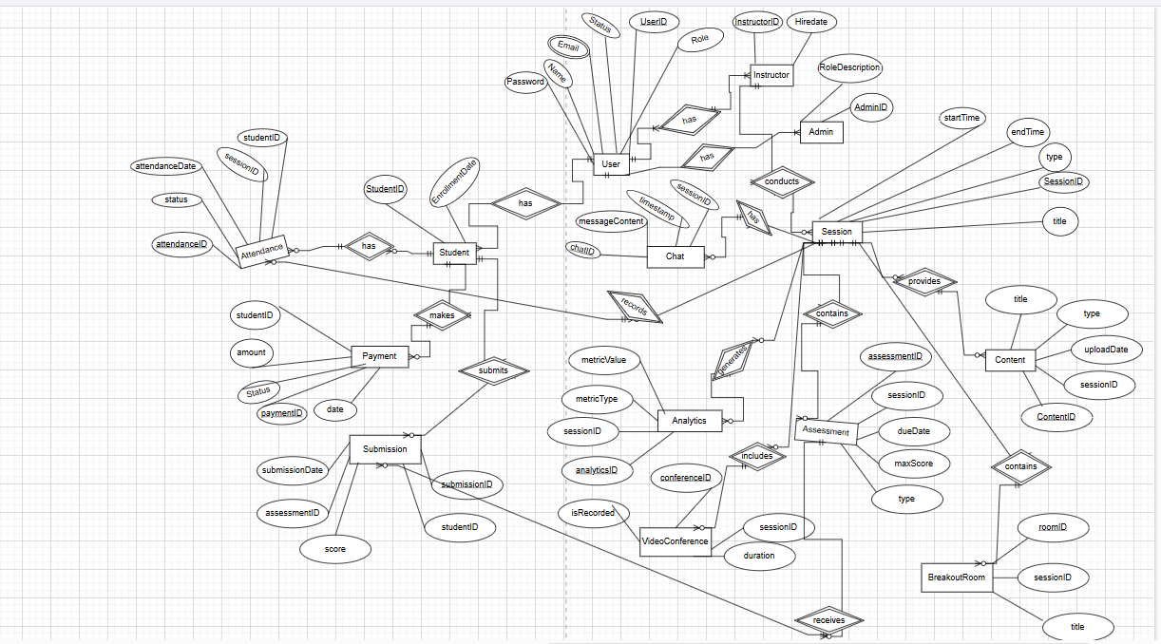

SOFTWARE DEVELOPMENT LIFE CYCLE

Process Model:
Selected Process Model: Agile Methodology (Scrum Framework)
The Agile methodology, specifically the Scrum framework, is selected for developing the Virtual Classroom Platform. Agile emphasizes iterative development, frequent feedback, and adaptability to change, making it highly suitable for the dynamic nature of the platform.

Arguments for Selecting Agile (Scrum)

- Flexibility in Requirements:
  - Educational needs evolve rapidly, especially with technological advancements. Agile allows frequent reassessment of requirements and easy integration of new features.

- User-Centered Development:
  - Scrum involves regular feedback from stakeholders (e.g., students, teachers, administrators) at the end of each sprint. This ensures the platform aligns with user expectations and delivers high usability.
- Iterative Delivery:
  - Agile’s sprint-based delivery ensures small, functional components (e.g., login system, video conferencing) are developed and tested incrementally. This reduces the risk of large-scale failures at the end.
- Focus on Quality:
  - Continuous testing and review in Agile minimize bugs and ensure that each feature is thoroughly validated before release.
  - Example: Testing the video conferencing module in multiple sprints ensures high-quality real-time communication.
- Collaboration:
  - Scrum’s daily standups and collaborative approach foster seamless communication between developers, designers, testers, and stakeholders, ensuring alignment with project goals.
- Time Efficiency:
  - Delivering functional increments in each sprint allows institutions to start using parts of the platform (e.g., assignment submission) even before the entire system is complete.
Evidence to Support Agile Selection
- Industry Precedent:
  - Agile is widely used in the development of dynamic, user-driven systems like e-learning platforms, mobile apps, and collaborative tools. Examples include platforms like Google Classroom and Microsoft Teams.
- Complexity Handling:
  - Virtual Classroom Platforms require the integration of multiple complex subsystems (e.g., live video streaming, data encryption, cloud storage). Agile’s modular approach simplifies the development and testing of these components.
- User Feedback in Real-Time:
  - Incorporating teacher and student feedback early ensures that features like screen sharing or breakout rooms work effectively and meet expectations.

- Risk Mitigation:
  - Incremental delivery ensures that potential risks (e.g., scalability issues) are identified and addressed early in development.

Project Role Identification and Responsibilities
The successful development of the Virtual Classroom Platform requires collaboration between multiple roles and stakeholders. Below is an identification of key roles and their responsibilities:

1. Project Manager

Responsibilities:
Plan, execute, and monitor the project to ensure it is completed on time, within scope, and within budget. Manage risks and resolve conflicts to ensure project success.

2. Product Owner
Responsibilities:
Gather and prioritize requirements from stakeholders (e.g., educators, students, institutions).Maintain the Product Backlog by defining user stories and acceptance criteria.
Ensure the development team focuses on features that add the most value to users.

3. Development Team
This includes Software Developers, Front-End Engineers, and Back-End Engineers.
Responsibilities:
Design, develop, and implement the platform’s features and functionalities.

4. UI/UX Designer
Responsibilities:
Design intuitive and visually appealing user interfaces for the platform. Conduct user research to ensure the platform is accessible and easy to use for a diverse audience. Create wireframes, prototypes, and design mockups for the platform's various components (e.g., dashboard, live class interface).

5. Quality Assurance (QA) Engineer
Responsibilities:
Develop test cases to validate the platform’s features and functionalities.
Perform functional, performance, and security testing to ensure the platform meets requirements.
Report bugs and work closely with developers to resolve issues.

6. Database Administrator (DBA)
Responsibilities:
Design and manage the database schema to store user data, course content, and activity logs securely. Optimize database performance and ensure data integrity. Implement backup and recovery procedures to prevent data loss.

7. Stakeholders (Educators, Students, Administrators)
Responsibilities:
Provide feedback on platform requirements, usability, and features. Participate in testing to ensure the platform meets real-world needs. Act as end-users who adopt and promote the platform within their institution.

8. Scrum Master (Specific to Agile Projects)
Responsibilities:
Facilitate Agile ceremonies (e.g., sprint planning, daily standups, retrospectives).Remove obstacles that block the team’s progress. Ensure the team adheres to Agile principles and practices. Foster collaboration among team members to achieve sprint goals.

9. End Users (Teachers, Students, and Administrators)
Responsibilities:
Use the platform for its intended purposes, such as hosting classes, attending lectures, or managing administrative tasks. Provide feedback to improve the platform’s features and usability.

